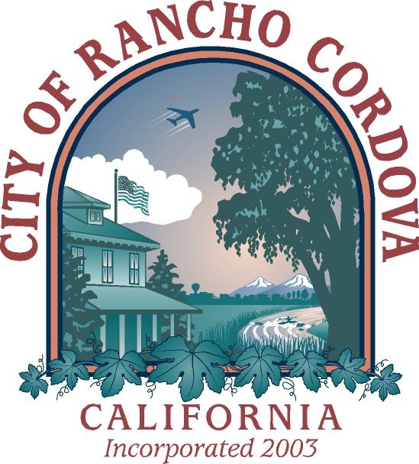
Dan Skoglund
Mayor

Ken Cooley
Vice Mayor

Linda Budge
Council Member

Robert J. McGarvey
Council Member

David Sander
Council Member

December 15, 2008

On October 20, 2008, the Rancho Cordova City Council adopted the Business and Multi-Family Recycling Ordinance (No. 20-2008). The intent of the Ordinance is to help the City comply with State law (AB 939), which requires every City and County in California to divert 50% of total solid waste generation from landfill disposal.

In summary, the new Ordinance requires all businesses and multi-family complexes in Rancho Cordova that subscribe to four cubic yards per week or more of solid waste collection service to meet the following requirements:
- Separate recyclable materials from solid waste;
- Provide for the collection of recyclables by either (choose one option):
  - Executing a written service agreement with your waste hauler or an authorized recycler; or
  - Self-hauling recyclables to an appropriate recycling facility.
- Post signage in your business or multi-family property where recyclables are collected;
- Educate employees or tenants about the program.

If you need assistance or additional information, please feel free to contact Steve Harriman, Integrated Waste Manager with the City of Rancho Cordova, at (916) 851-8718, or by email at sharriman@cityofranchocordova.org.

Sincerely,

Steve Harriman
Integrated Waste Manager

2729 Prospect Park Drive Rancho Cordova, CA 95670 (916) 851-8700 Fax (916) 851-8787 www.cityofranchocordova.org

